**Power BI Assignment 5**

1. **Explain DAX.**

Data Analysis Expressions (DAX) is a formula expression language used in Analysis Services, Power BI, and Power Pivot in Excel. DAX formulas include functions, operators, and values to perform advanced calculations and queries on data in related tables and columns in tabular data models. DAX formulas are used in measures, calculated columns, calculated tables, and row-level security.

DAX is also known as function language, where the full code is kept inside a function. DAX programming formula contains two data types: Numeric and Other. Numeric includes - integers, currency and decimals, while Other includes string and binary object.

1. **Explain datasets, reports, and dashboards and how they relate to each other?**
2. **Dataset**

A Power BI Dataset is a series of Power Query queries that have been shaped in a DAX model. Each dataset can combine different files, database tables and online services all into one tabular model.

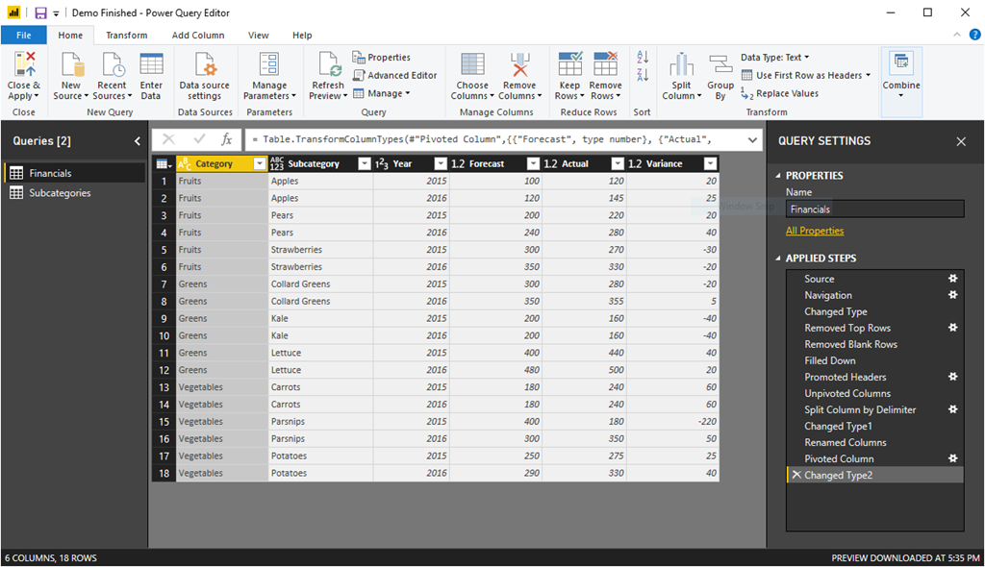

1. **Reports**

A Report is a multi-perspective view of a dataset, with visuals representing different findings and insights.

A power BI report is a series of visualizations, filters and static elements on a canvas. Power BI reports are saved as a single PBIX file and connect to a single dataset.

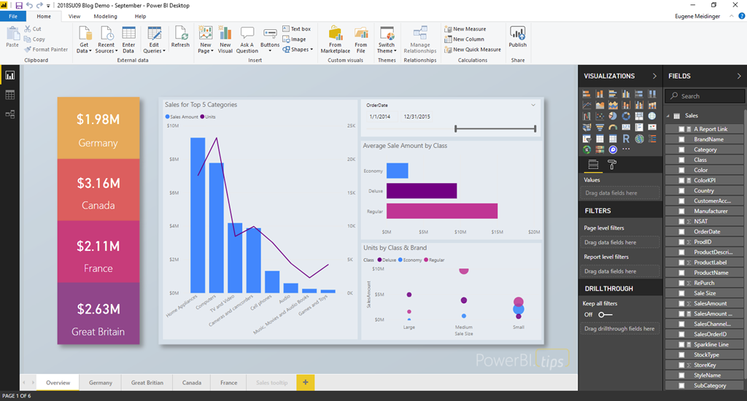

1. **Dashboard**

A Power BI **dashboard** is a single page, often called a canvas, that uses visualizations to tell a story. Because it is limited to one page, a well-designed dashboard contains only the most-important elements of that story.

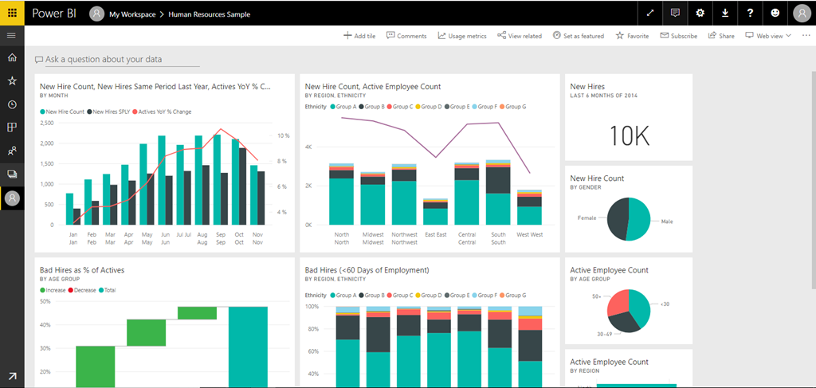

1. **How reports can be created in power BI, explain two ways with Navigation of each.**

Step 1: Install Power BI Desktop for Power BI Report Server

Step 2: Select a data source

Step 3: Design your report.

Step 4: Save your report to the report server.

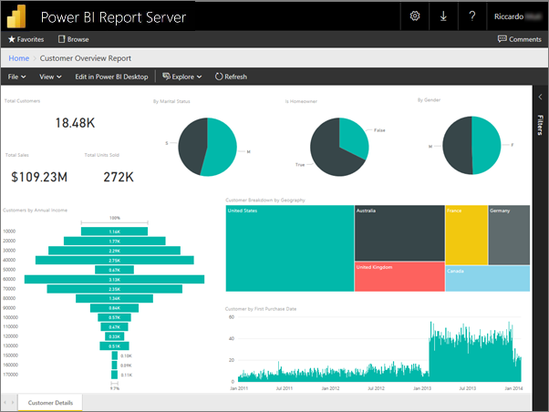

1. **How to connect to data in Power BI? How to use the content pack to connect to google analytics? Mention the steps.**

**Steps to Connect Data in Power BI**

1. In Power BI Desktop, select Get data from the Home ribbon tab.
2. In the Get Data window, select Online Services from the categories in the left pane.
3. Select Google Analytics from the selections in the right pane.
4. At the bottom of the window, select Connect.

**Steps to Connect to the Google Analytics content pack in POWER BI**

1. In the left navigation pane, click Get Data.
2. In the Services box, click Get.
3. From the menu of online services, select Google Analytics, and then click Connect.
4. Enter the Google Analytics account, property, and view that you want to connect to. Then sign in with your Google Analytics credentials.
5. To permit Power BI to connect to Google Analytics, click Accept.
6. When the import process completes, you will see a new dashboard, report, and model in the Navigation Pane. Select the dashboard to view your imported data.

**4)How to import Local files in Power BI? Mention the Steps.**

1. In Power BI, click Get Data in the lower left screen.
2. Under Import or Connect to Data > Files, click Get.
3. Click Local File.
4. Choose which file to upload and click Open.
5. Click Upload under Upload your Excel file to Power BI.
6. The message “Your file has been uploaded” should appear.

**5)In Power BI visualization, what are Reading View and Editing view?**

 Reading view for report business users and used to consume reports created by others.

Editing view for report owners and creators. Editing view is used by report designers, who create the reports and share.

Reading View is a view of the report that is intended for users to consume the report's content and interact with the visualizations. This view allows users to filter, highlight, and drill down into the data, as well as access additional features such as exporting the report or printing it.

Editing View is a view of the report that is intended for report creators and designers to build and modify the report. In this view, you can add, remove, and modify visualizations, change the layout and design of the report, and add or modify any interactions or filters. You can also access the data model and make changes to the underlying data used in the report.